1 Introduction 1
2 Features of the solutions 1
2.1. Choice of parameters 2
3 Finite-volume form of the 2-D Euler equations 3
4 Roe’s flux function in 2-D 4
4.1 Entropy fix 5
5 Boundary procedures 6
5.1 Wall boundary 6
5.2 Far-filed boundary 6
6 Non-Dimensional form 7
7 Marching to a steady state 7
7.1 Definition of the CFL number 9
7.2 Initial values 9
7.3 Preserving uniform flow 9
7.4 Preserving symmetry 10
8 Numerical experiments 10
9 Desired output 10

Introduction
You now have the tools to compute the steady inviscid flow about an airfoil. You know how to obtain interface data from cell-centered data, how to combine two interface state vectors into one flux vector with a numerical flux function, how to implement far-field and wall boundary conditions, how to march in time with multi-stage methods, how to formulate the Euler equations on a 2-D grid and how to generate a 2-D grid.
Some of the above steps are briefly re-iterated bellow to help you develop your own 2-D “Euler Solver”. As before, you’ll test a new numerical algorithm, a multi-stage method recently developed for optimal short-wave damping in the 1-D scalar case; see Van Leer, Tai & Powell (Appendix 1)
To get the best accuracy for your CPU time you will use the second-order upwind finite volume scheme based on linear distributions inside each cell; see computer problem #1, Equations (47), (48). The flux function will be Roe’s, in order to keep a reasonable accuracy. All calculations will be for a NACA 0012 on a grid of 32 of cells. Use finer grids.

Features of the solutions
The steady solutions you are about to compute are determined by two parameters: the flow Mach number 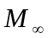and the angle of attack; see Figure.6. In computations the chord of the airfoil is always aligned with the x-axis; the angle of attack is prescribed by rotating the inflow-velocity vector.
For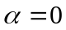, a symmetric airfoil like NACA 0012 creates about itself a symmetric flow without “lift”; lift is what aerodynamicists call the component of pressure force acting on the airfoil in the direction normal to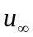. For 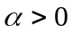 , the lift will be positive. The component of the force in the direction of is called “Drag”; this force vanishes for inviscid flow. For Mach number approaching or exceeding unity, shocks appear in the solution and drag arises: the so-called “wave drag”.
Inviscid solutions are not uniquely determined by the boundary conditions: a selection criterion based on the properties of viscous flow must be added to the Euler equations selected the flow realize in practice. This is the “Kutta Condition”, which says that the flow is not turn the sharp corner of trialing edge. This means that the pressure on the upper and lower surface must tend to the same value toward the trailing edge. In a dissipative approximation of the Euler equations, the artificial viscosity takes care of establishing this flow pattern.
Equally important is the “Kutta-Joukowski” theorem which says that the lift acting on the airfoil is proportional to the circulation about the airfoil seen from a large distance; the flow disturbance created by the airfoil appears that of a point vortex; this approximation is well to specify the flow field at the far boundary of the computational domain.

2.1. Choice of parameters
You will choose the values of the parameter pair (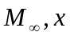) among cases that are well documented, in particular:
(1) 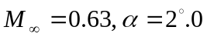 (No shocks)
(2) 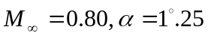 (Upper shock strong, lower shock weak)
(3) 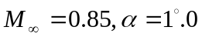 (Shocks comparable strength)
(4) 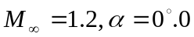 (Bow and fish-tail shocks no lift)
Non-dimensional (cited in the literature) lift and drag values for this cases are given in the table below:

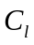 |  |  |  | 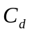
case | 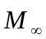 |  | best values |  | spread | best values |  | spread
(1) GAMM | 0.63 | 2.00 | 0.3335 |  | 0.329-0.336 | 0.00003 |  | 0.00003-0.0007
(2) AGARD | 0.80 | 1.25 | 0.3632 |  | 0.3463-0.3736 | 0.0230 |  | 0.0221-0.0244
(3) GAMM | 0.85 | 1.00 | 0.379 |  | 0.330-0.3965 | 0.0576 |  | 0.0507-0.0596
(4) AGARD | 1.20 | 0.00 | 0 |  | 0 | 0.0960 |  | 0.0446-0.0960
Table 1. Lift and drag coefficients taken from the results two CFD competitions.

High quality solutions offered for the above flow cases are displayed in figures 10-13.

Finite-volume form of the 2-D Euler equations
The finite-volume form of the Euler equations that is to be used can be written as:
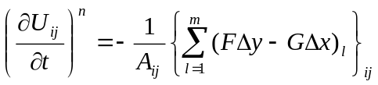 Equation 1

Where 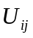 represents the vector of cell-averaged conserved quantities for cell (i, j), 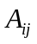 is the area of cell (i, j), the index denotes the sequence of cell faces on the cell boundary 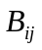, 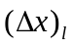 and 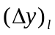 are the changes of y and x along the -th cell face going in the counter-clockwise direction and 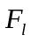 and 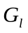 are cell-face averaged values of the flux vectors in the Cartesian reference; see Figure 1. Obviously, any term included in the sum on the right-hand side of Equation (1) will turn up with the opposite sign in the sum of one of the neighboring cells.
For the purpose of reference y repeat:

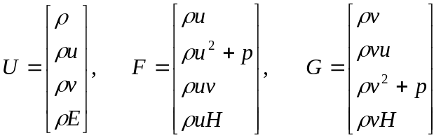 Equation 2

Given representative (averaged) values 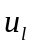 and 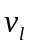 on the cell-face , and using the cell-face length:

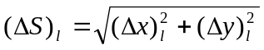 Equation 3

We may write the outward velocity normal to the cell-face (see Figure 2) as:

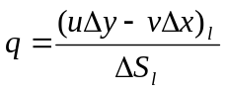 Equation 4

and the outward flux normal to the cell-face as:

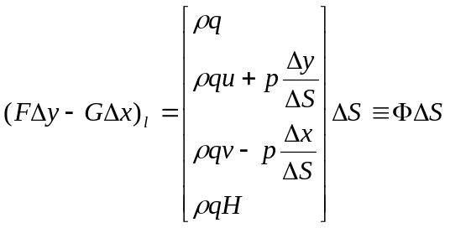 Equation 5

For future reference: the velocity parallel to the call-face can be written as:

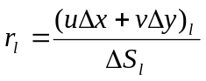 Equation 6
Furthermore:

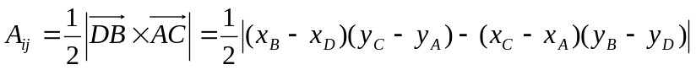 Equation 7
See Figure 3.

Roe’s flux function in 2-D
In the numerical algorithms we’ve adopted for the Euler equations, we don’t have a single value of U, F and G at each cell-face, but a pair of values. We shall adopt the usual notation with subscripts L and R for “left” and “right” states. The left state refers to the cell with the lower index. More specifically: if L refers to the state on the side of cell (i, j) at interface (i+1/2, j) then R refers to the state on the side of cell (i+1, j). If L refers to the side of cell (i, j) at interface (i, j+1/2), then R refers to (i, j+1); see Figure 4.
The formula for the flux outward of cell L according to Roe’s Riemann solver, is (subscript dropped)

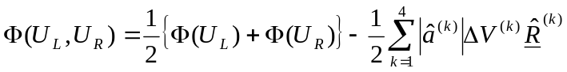 Equation 8

With

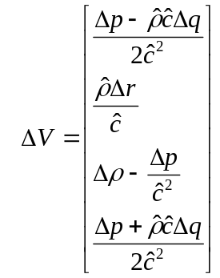Equation 9 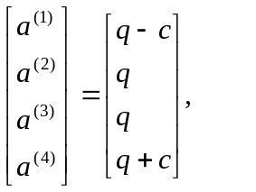 Equation 10

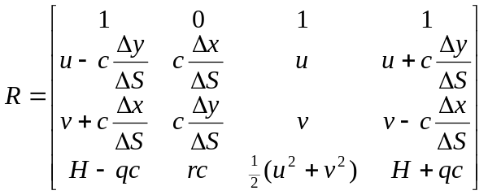 Equation 11

Note that 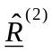 contains a factor that is cancelled by the factor in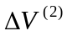; these factors are maintained in order to achieve uniform physical dimensions.
The Roe-averages 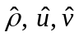 and 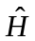 are obtained usual from 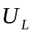 and 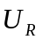; follows from , and as usual, and and follow from (4) and (7) by inserting “hetted” value of u and v.

Entropy fix
You may never see any expansion shock arising in your 2-D solution, but the solution may be fighting them off, at the expanse of the convergence rate. Better include the following “entropy fix” (see Figure 5) use 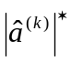 instead of 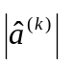for k=1 and 4:

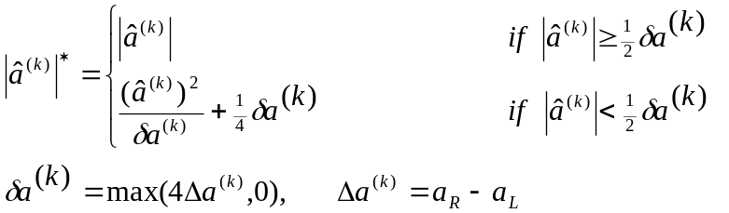 Equation 12

Boundary procedures

Wall boundary
At a cell-face that is part of the airfoil, the normal velocity q vanishes, so that only the pressure terms in the flux(S) remains. This boundary condition can be implemented by the follow boundary procedures:

- Don’t solve the Riemann problem; just use the flux(S) with the pressure from the adjacent cell (j=1)
- Create a ring of “mirror cells” across the ring (j=0), with all primitive variables equal those in the first ring (j=1) except for the velocity normal to the wall, which is reflected; see Figure 7. Stay in the computational domain, don’t bother drawing these cells in the physical domain. Using a single set of values 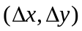 for the interface of cells (0,0) and (I,1), namely, the values defined in the “left” cell (j=0), the flow in the mirror cell is given by

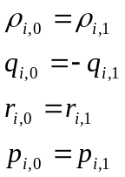 Equation 13

You may now use Roe’s formula for the wall fluxes.
The second approach is more robust, but is more dissipative. This shows up in the form of some entropy production along the wall.

Far-filed boundary
Beyond the last ring of cells (j=J), create an extra ring of cells (j=J+1) in which the asymptotic far-filed solution is prescribed. i.e. uniform flow on which is superimposed the circulatory flow caused by a point vortex at the mid-point of the airfoil’s chord. The vortex strength follows from the instantaneous circulation Γ computed at the airfoil; the flow induced by this vortex is computed from small-disturbance theory, with the effect of compressibility induced through Prantle-Glaurt transformation (See, e.g. Fundamentals of Aerodynamics, 3rd edition, Sec. 12.3). The fluxes at j=J+1/2 are computed, once more, with the Standard Roe formula.
In the following formulas, C denotes the chord length, (R, ν) are polar coordinates with the origin at x=C/2, y=0 (Fig. 8). Define
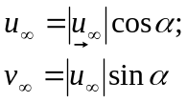 Equation 14
Then
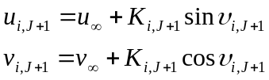 Equation 15
With
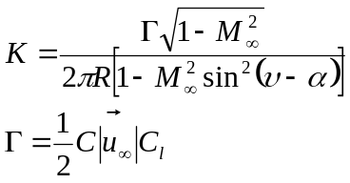 Equation 16
The thermodynamic variables now follow from constancy of total enthalpy and entropy:
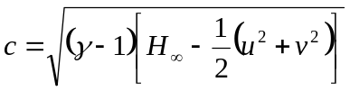, 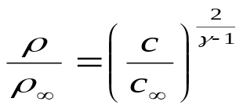 , 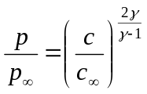 Equation 17

Equations 15 and 16 are to be used only for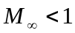, i.e. in the cases (1), (2) & (3). For the symmetric supersonic flow of case (4), just describe at I+1.

Non-Dimensional form
Reference length: C;
reference density: 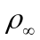;
refernce velocity: 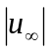

Marching to a steady state
The marching method is an m-stage method defined by
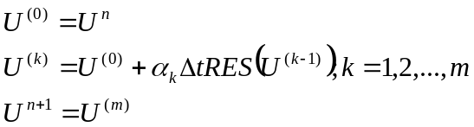 Equation 18
The time step fractions α_{k} and the time step are chosen such as to optimally damp a specific range of special frequencies from given number of stages. This analysis strictly applies only to a one-dimensional scalar equation; see Van Leer, Tai & …. (Appendix 1). For full applicability to the two-dimensional Euler equations, a technique called “characteristic time-stepping” must be employed, but this remains to be developed ().
For the moment, you must be satisfied with “local time-stepping”, which means: the use of the same CFL number in all cells rather than the same Δt in all cells.
The values of the α_{k} for different values of m and different intervals of the wave number β over which damping has been minimized, are given below for 1st 0rder upwind differencing. In this case, the optimal CFL number ν_{m} always equals m/2. this table is valid only for 1st 0rder upwind differencing, for the 2nd order scheme you are using, consult Table 2 of Van Leer, Tai & Powell; and the entries in table 5 of the same for k=-1.

 | Damping minimized for
 | 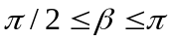 |  |  | 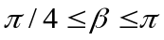 |  | 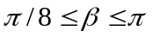
M | 4 | 6 | 8 | 6 | 8 | 6 | 8
ν_{m} | 2.0 | 3.0 | 4.0 | 3.0 | 4.0 | 3.0 | 4.0
α₁ | 0.0 33 | 0.0370 | 0.0208 | 0.0485 | 0.0272 | 0.0535 | 0.0301
α₂ | 0.2069 | 0.0851 | 0.0462 | 0.1120 | 0.0607 | 0.1267 | 0.0681
α₃ | 0.4265 | 0.1521 | 0.0780 | 0.1944? | 0.1026 | 0.2324 | 0.1176
α₄ | 1 | 0.2562 | 0.1206 | 0.3285 | 0.1571 | 0.3973 | 0.1844
α₅ |  | 0.4512 | 0.1813 | 0.5477 | 0.2318 | 0.6 76 | 0.2791
α₆ |  | 1 | 0.2778 | 1 | 0.3433 | 1 | 0.4232
α₇ |  |  | 0.4634 |  | 0.5378 |  | 0.6693
α₈ |  |  | 1 |  | 1 |  | 1
Table 2. parameters of optimal multi-stage methods recommended methods: 6 stages;

Definition of the CFL number
The 1st order upwind convection scheme is stable for
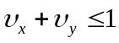 Equation 19
For the 2-D Euler equations these becomes
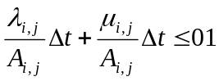 Equation 20
With
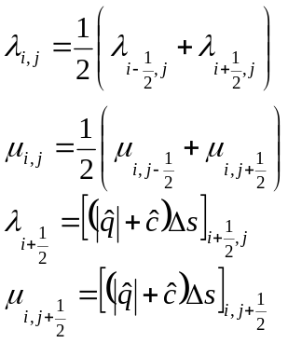 Equation 21

For the m-stage methods described above, use

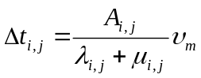 Equation 22

Initial values
For the lifting cases, you may use as initial values the asymptotic solution, given in eqs (14)-(17) for j=J+1, in rings of cells closer to the airfoil, for instance, down to j=J’, with min R_{i,J’}>= 1.5C. This helps set up the circulation away from airfoil, two accelerating convergence to a steady-state. In the inner part of the computational region you may phase this solution out by freezing the value of R_{i,j} in the formula at the value R_{i,J’}. get a good testing value for Γ from table 1.

Preserving uniform flow
By prescribing in all cells, including the rings at j=0 and j=J+1, you can test if your scheme preserves uniform flow. This will tell you if you have programmed the geometric terms in the fluxes correctly, i.e. the Δx’s & Δy’s. try α=0 and non zero values. This test does not screened the term 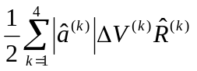in the flux formula (8), as all 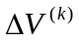 vanish for uniform flow. Use the one-stage scheme (forward Euler) with ν₁=0.5, then try a multi-stage scheme.

Preserving symmetry
For α=0, test if your results remain symmetric.

Numerical experiments
Run at least the case (1), (3) & (4) from sec. 2.1 until the solutions are steady within some numerical margin that does not require prohibitive amounts of CPU time. Case (2) may be harder to bring convergence. In the lifting cases (1),(2) &(3) you may use the lift coefficient as an indicator of convergence: stop when it is convergent in 3 decimal places. Use a 32*16 O-grid.
If you have time for it, do a grid-refinement study, using e.g. 64*32 & 96*32 O-grids. This is especially interesting for case (1), where the drag should go to zero, and the lift is accurately known from potential theory, and case (2), where the weak lower shock may be hard to resolve.
More dramatic improvement in resolution will come from introducing the one-sided extrapolation of cell values toward cell faces. For an oscillation-free steady state you don’t need limiters, but you may need these in marching toward the steady state. You will need other values of α_{k} and ν_{m}(Appendix 1, tables 2 & 5, k=-1). Convergence may not be reached easily. Those who couldn’t pull it off in computer profile #1 are not allowed to touch the 2nd order scheme this time.

Desired output
Make contour plots of M, the pressure coefficient
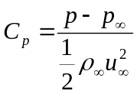 Equation 23
And the entropy variation

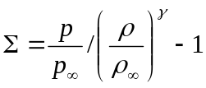 Equation 24
In order to convert cell-centered values into cell-vertex values, use the interpolation formula for any quantity Q:

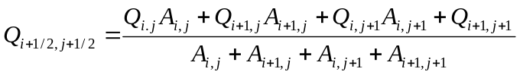 Equation 25

For cell-vertices on the airfoil, make use of the mirror cell-values(13), while defining mirror-cell volume by
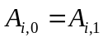 Equation 26
In the mach number plots, be sure to include the M=1 contour, which outlines the regime of supersonic flow.
Make symbol plots of the 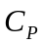and distribution on the airfoil, as a function of x. There will be two branches: one for the upper and one for the lower surface (see Figure 10-13). Note that is traditionally plotted upside .
Provide a residual history for each run, and also a history for the convergence of 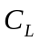and 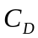 to their steady values. For cases (2) and ( ) and interesting quantity to monitor is the number of supersonic cells, which is correlated with the convergence of lift.
Tabulate values of and for the converged solution.
In your write-up, compare your results with those from literature. Discuss the accuracy you have achieved, with the referring to the plots and values you submit. Explain this appearing Res. You will find C_{l} values that are too low and C_{d} values that are substantially greater than zero, even for fully subsonic flow.
Finally here are the formulas for and . First compute the net pressure force on the airfoil according to
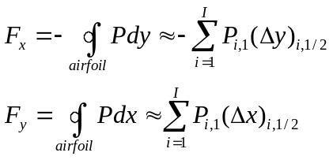 Equation 27
Then the sectional lift and drag follows from
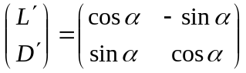 Equation 28
And the corresponding coefficient from
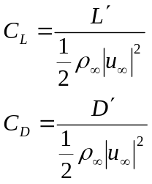 Equation 29

See Figure 9. Note that the area enclosed by the 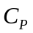curve you're plotted (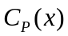on airfoil) represents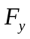.

Good Luck !

